Insert your centre number, name and candidate number into the header above.
Save this evidence document as evidence_ followed by your centre number_ candidate number. For example: evidence_ zz999_9999
Screenshots or program listings must be copied into appropriate cells in the following table.
Examiners must be able to read the contents including any screenshots without the use of a magnifying glass. Answers that are not readable or missing will not be awarded any marks.
Save this evidence document at regular intervals, for example every 10 minutes.
Question 1
Part 1(a)
global StackData #integer
global StackPointer
StackData = [0,0,0,0,0,0,0,0,0,0] #integer
StackPointer = 0

Part 1(b)
def PrintArray():
global StackData
global StackPointer
print("Stack Pointer is: ", StackPointer)
for x in range(0,10):
print(StackData[x])

Part 1(c)
def Push(DataToPush):
global StackData
global StackPointer
if StackPointer == 10:
return False
else:
StackData[StackPointer] = DataToPush
StackPointer = StackPointer + 1
return True

Part 1(d)(i)
#main
StackPointer = 0
StackData = [0,0,0,0,0,0,0,0,0,0]
for x in range(0,11):
TempNumber = int(input("Enter a number"))
if Push(TempNumber) == True:
print("Stored")
else:
print("Stack full")
PrintArray()

Part 1(d)(ii)
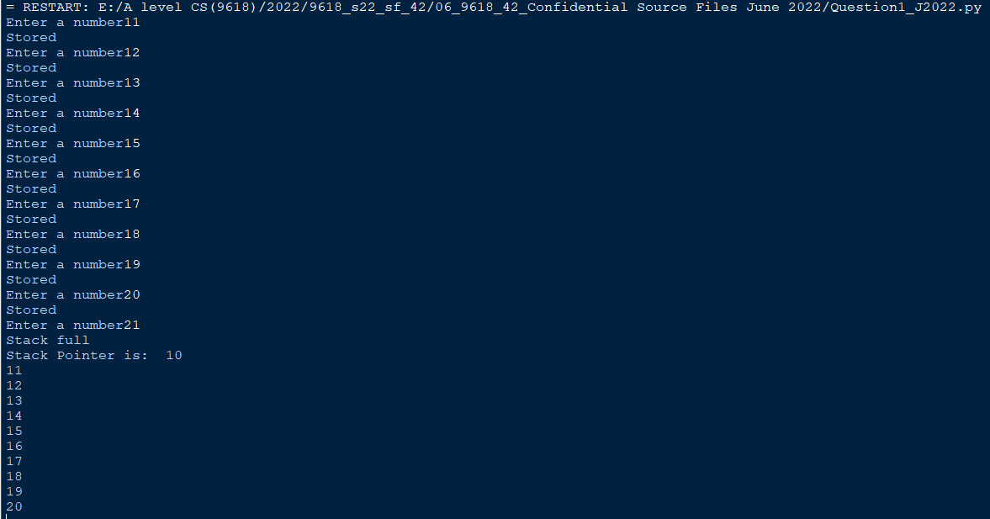

Part 1(e)(i)
def Pop():
global StackData
global StackPointer
if StackPointer == 0:
return -1
else:
ReturnData = StackData[StackPointer-1]
StackPointer = StackPointer - 1
return ReturnData

Part 1(e)(ii)
Code:

Pop()
Pop()
PrintArray()

Screenshot:
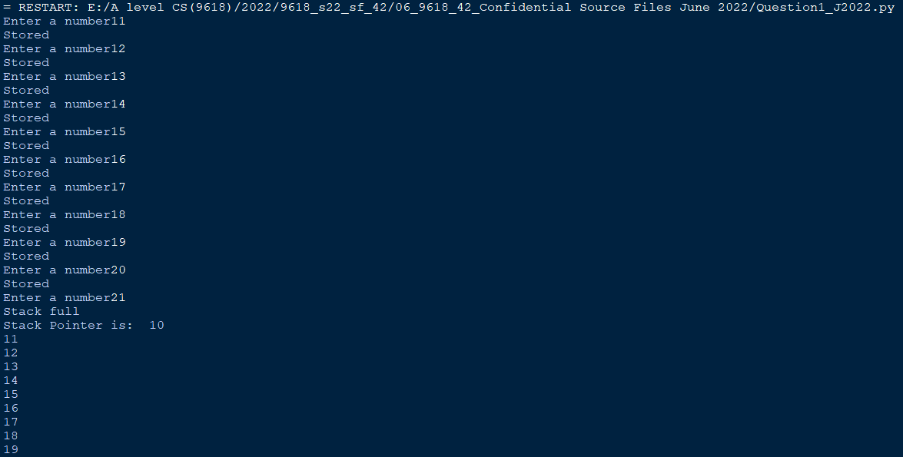
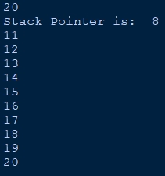

Question 2
Part 2(a)
import random
#main
ArrayData = [[0]*10 for i in range(10)] # integer
for x in range(0,10):
for y in range(0,10):
ArrayData[x][y] = random.randint(1,100)

Part 2(b)(i)
ArrayLength = 10
for X in range(0, ArrayLength):
for Y in range(0, ArrayLength-1):
for Z in range(0, ArrayLength-Y-1):
if (ArrayData[X][Z] > ArrayData[X][Z+1]):
TempValue = ArrayData[X][Z]
ArrayData[X][Z] = ArrayData[X][Z+1]
ArrayData[X][Z+1] = TempValue

Part 2(b)(ii)
import random

def PrintArray(ArrayData):
for x in range (0,10):
for y in range(0,10):
print(ArrayData[x][y], " ", end='')
print("")

#main
ArrayData = [[0]*10 for i in range(10)] # integer
for x in range(0,10):
for y in range(0,10):
ArrayData[x][y] = random.randint(1,100)

print("Before")
PrintArray(ArrayData)
ArrayLength = 10
for X in range(0, ArrayLength):
for Y in range(0, ArrayLength-1):
for Z in range(0, ArrayLength-Y-1):
if (ArrayData[X][Z] > ArrayData[X][Z+1]):
TempValue = ArrayData[X][Z]
ArrayData[X][Z] = ArrayData[X][Z+1]
ArrayData[X][Z+1] = TempValue

print("After")
PrintArray(ArrayData)

Part 2(b)(iii)
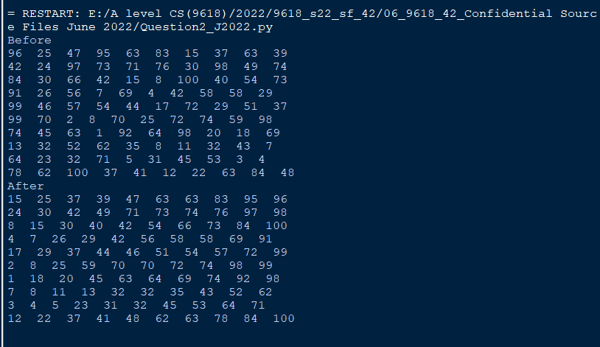

Part 2(c)(i)
def BinarySearch(SearchArray, Lower, Upper, SearchValue):
if Upper >= Lower:
Mid = int((Lower + Upper) / 2)
if SearchArray[0][Mid] == SearchValue:
return Mid
elif SearchArray[0][Mid] > SearchValue:
return BinarySearch(SearchArray, Lower, Mid-1, SearchValue)
else:
return BinarySearch(SearchArray, Mid+1, Upper, SearchValue)
return -1

Part 2(c)(ii)
Code:

FirstCheck = int(input("Enter the number: "))
print(BinarySearch(ArrayData, 0, 9, FirstCheck))
SecondCheck = int(input("Enter the number: "))
print(BinarySearch(ArrayData, 0, 9, SecondCheck))

Screenshot:
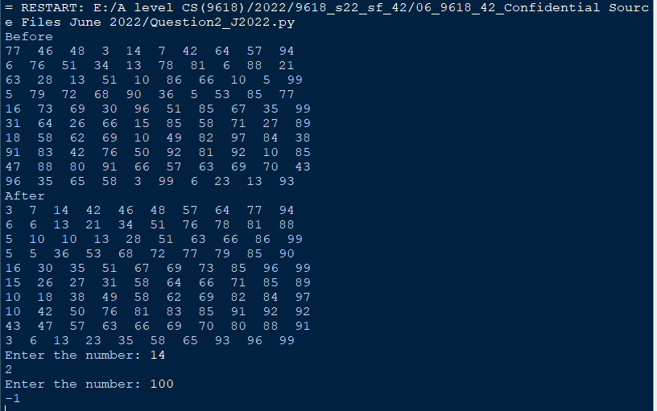

Question 3
Part 3(a)
class Card:
#Number as Integer
#Colour as string
def __init__(self, Numberp, Colourp):
self.__Number = Numberp
self.__Colour = Colourp

Part 3(b)
def GetNumber(self):
return self.__Number
def GetColour(self):
return self.__Colour

Part 3(c)
CardArray = [0,0,0,0,0,0,0,0,0,0,0,0,0,0,0,0,0,0,0,0,0,0,0,0,0,0,0,0,0,0] #integer
try:
Filename = "CardValues.txt"
File = open(Filename,'r')
for x in range(0,30):
NumberRead = int(File.readline().strip())
ColourRead = File.readline().strip()
CardArray[x] = Card(NumberRead, ColourRead)
File.close()
except IOError:
print("Could not find file")

Part 3(d)
global NumbersChosen
#main
NumbersChosen = [False for i in range(30)]

def ChooseCard():
global NumbersChosen
flagContinue = True
while flagContinue == True:
CardSelected = int(input("Select a Card from 1 to 30"))
if CardSelected < 1 or CardSelected > 30:
print("Number must be between 1 and 30")
elif NumbersChosen[CardSelected-1] == True:
print("Already taken")
else:
print("Valid")
flagContinue = False
NumbersChosen[CardSelected-1] = True
return CardSelected-1

Part 3(e)(i)
Player1 = [] #of type Card
for x in range(0, 4):
ReturnNumber = ChooseCard()
Player1.append(CardArray[ReturnNumber])
for x in range(0,4):
print(Player1[x].GetNumber())
print(Player1[x].GetColour())

Part 3(e)(ii)
